Project Report

Qin He

272486

Mandatory tasks 1

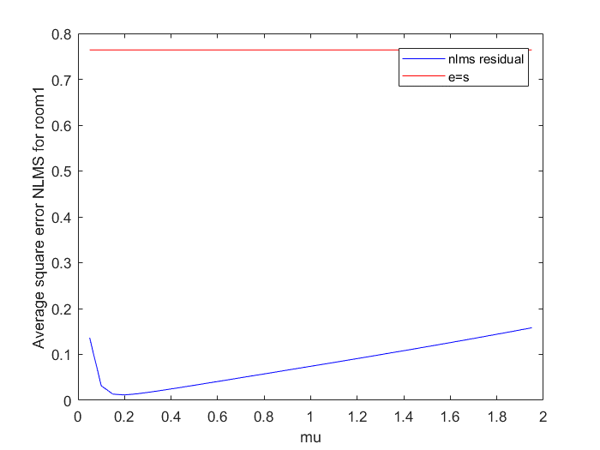

Figure 1.1.1 The average square error of NLMS (room1 with unstructured noise)with different steps mu

Figure 1.1.1 shows us the speech signal “speech_and_noise_source_through_room_1.wav” with adaptive noise cancelling of noise signal “noise_cource.wav” changing with different steps mu. As the step size is 0.15, the average square error reaches the minimum. When the mu increases from it to 2, the ASE rises again.

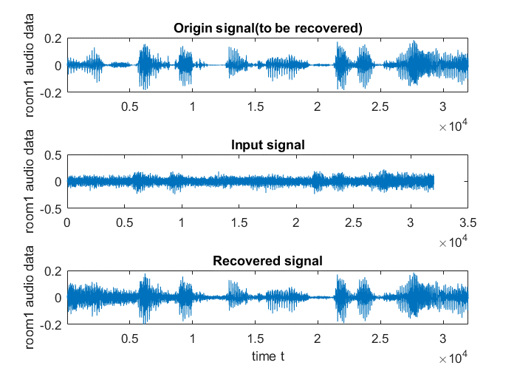

Figure 1.1.2 the comparison of the signal of origin, input and recovered(room1 with unstructured noise).

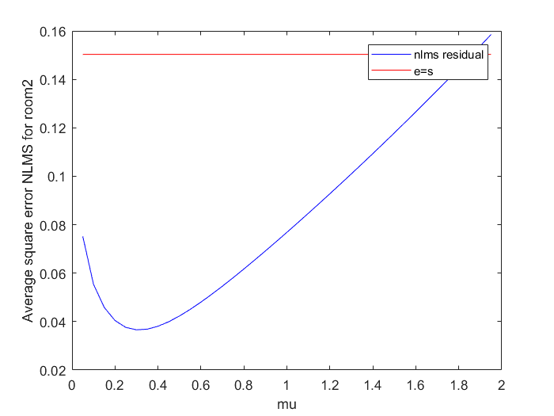

Figure 1.2.1 The average square error of NLMS (room2 with unstructured noise)with different steps mu

Similarly, Figure 1.2.1 shows us the speech signal “speech_and_noise_source_through_room_2.wav” with adaptive noise cancelling of noise signal “noise_cource.wav” changing with different steps mu. As the step size is 0.3, the average square error reaches the minimum. When the mu increases from it to 2, the ASE rises again.

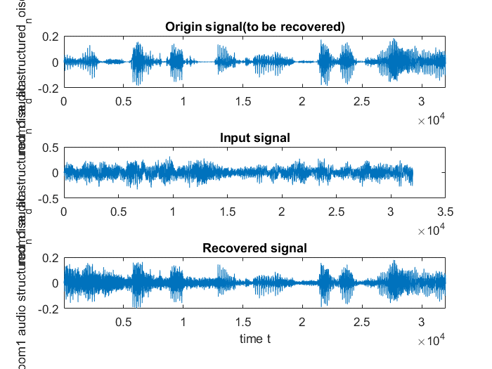

Figure 1.2.2 the comparison of the signal of origin, input and recovered(room2 with unstructured noise).

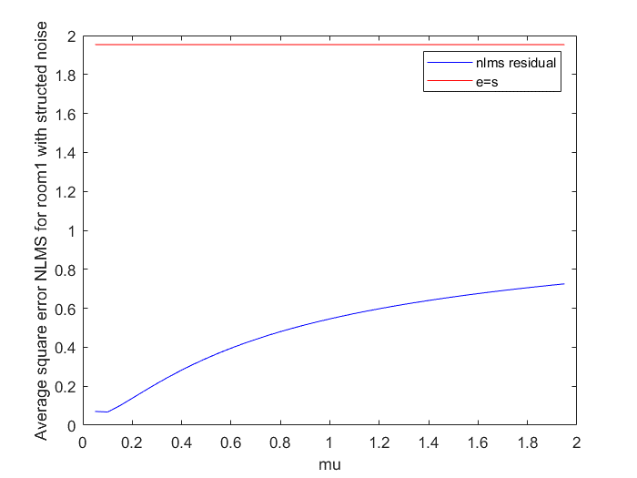

Figure 1.3.1 The average square error of NLMS (room1 with structured noise)with different steps mu

Figure 1.3.1 shows us the speech signal “speech_and_structured_noise_source_through_room_1.wav” with adaptive noise cancelling of noise signal “structured_noise_cource.wav” changing with different steps mu. As the step size is 0.1, the average square error reaches the minimum. When the mu increases from it to 2, the ASE rises again.

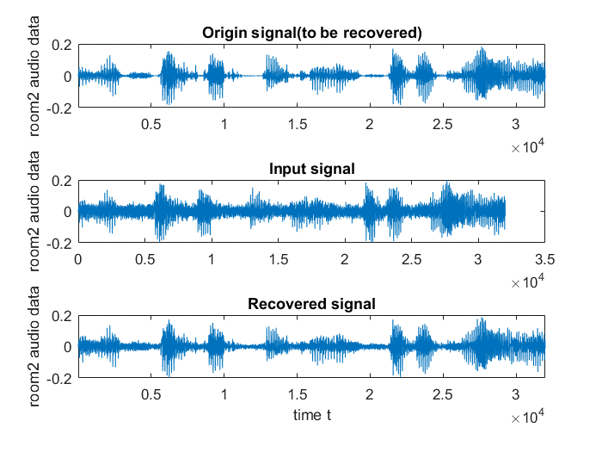

Figure 1.3.2Comparison of origin, input and recovered(room1 with structured noise).

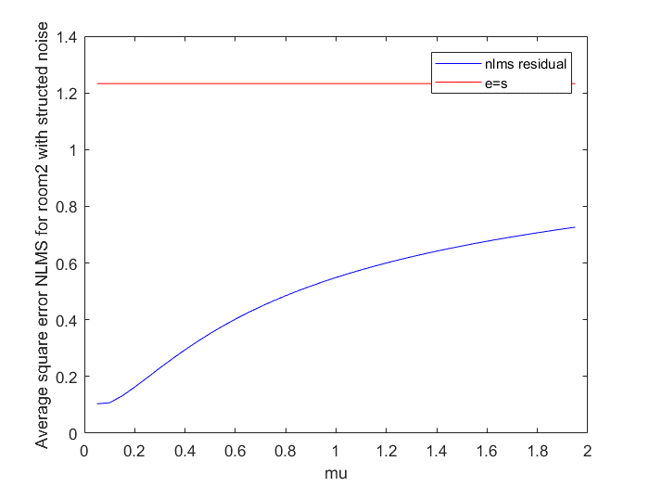

Figure 1.4.1 The average square error of NLMS (room2 with structured noise)with different steps mu

Figure 1.4.1 shows us the speech signal “speech_and_structured_noise_source_through_room_2.wav” with adaptive noise cancelling of noise signal “structured_noise_cource.wav” changing with different steps mu. As the step size increases, the ASE keeps increasing.

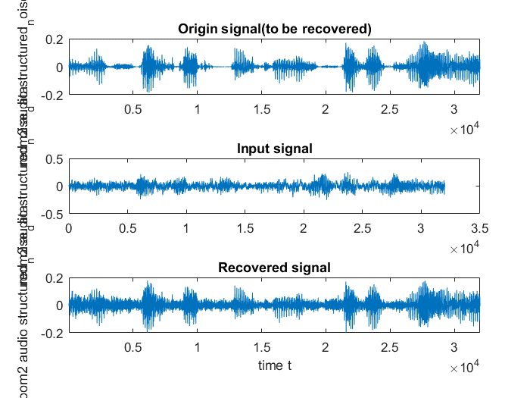

Figure 1.4 2 Comparison of origin, input and recovered(room2 with structured noise).

For all four signals, the filtered ASE are all smaller than unfiltered ones. And the NLMS works better for unstructured noise than structured one.(Smallter ASE with minimum mu.) And they all goes not to converge with larger mu than the optimal values.

Task 2

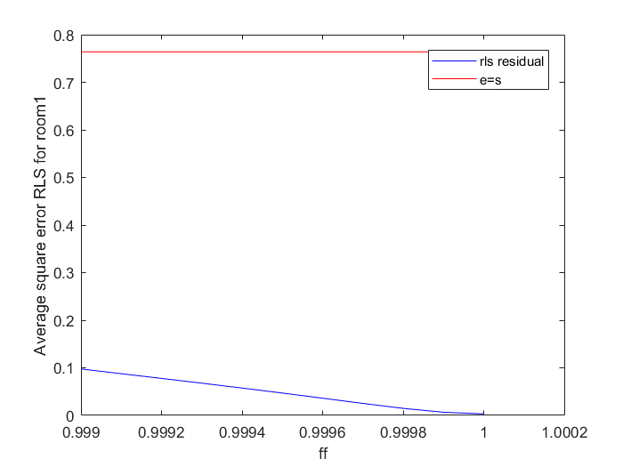

Figure 2.1.1 The average square error of RLS (room1 with unstructured noise)with different forget factor ffs.

Figure 2.1.1 shows us the speech signal “speech_and_noise_source_through_room_1.wav” with adaptive noise cancelling of noise signal “noise_cource.wav” changing with different ffs. As the ff increases, the ASE keeps decreasing.

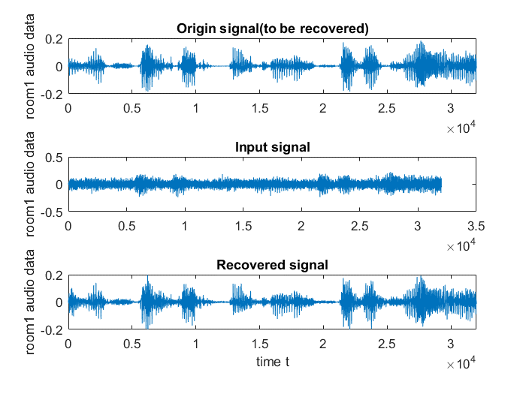

Figure 2.1.2 the comparison of the signal of origin, input and recovered(room2 with unstructured noise).

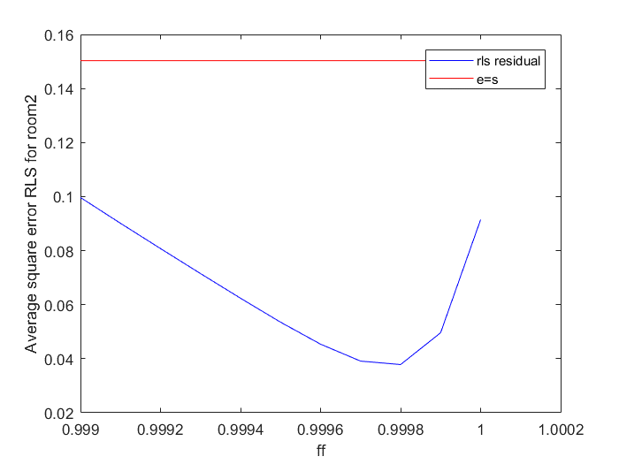

Figure 2.1.1 The average square error of RLS (room2 with unstructured noise)with different forget factor ffs.

Figure 2.2.1 shows us the speech signal “speech_and_noise_source_through_room_2.wav” with adaptive noise cancelling of noise signal “noise_cource.wav” changing with different ffs. As the ff is 0.9998, the ASE is the smallest, and when it keeps increasing to 1, the ASE rises again.

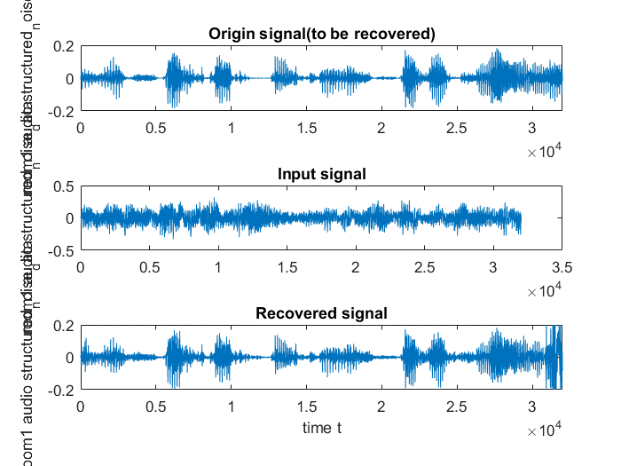 Figure 2.2.2 the comparison of the signal of origin, input and recovered(room2 with unstructured noise).

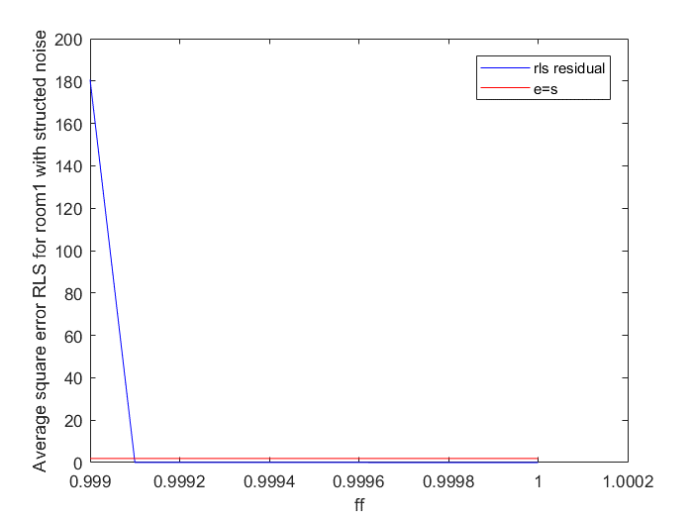

Figure 2.1.1 The average square error of RLS (room1 with structured noise)with different forget factor ffs.

Figure 2.2.1 shows us the speech signal “speech_and_structured_noise_source_through_room_1.wav” with adaptive noise cancelling of noise signal “noise_cource.wav” changing with different ffs. As the ff increses to 0.9991, the ASE reaches the smallest sharply, and when it keeps increasing to 1, the ASE doesn’t change. But in total, the ASE are large, shows us it is not converge before the optimal ff.

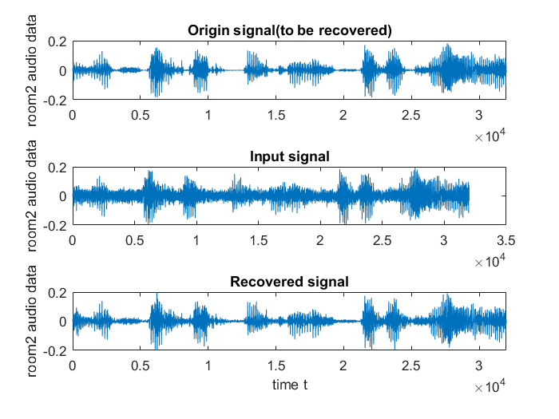

Figure 2.3.2 the comparison of the signal of origin, input and recovered(room1 with structured noise).

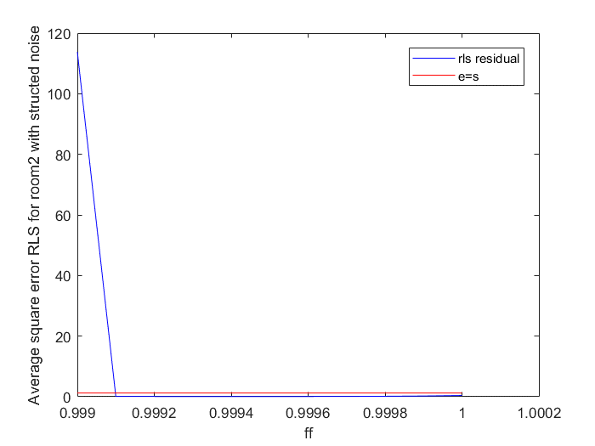

Figure 2.4.1 The average square error of RLS (room2 with structured noise)with different forget factor ffs.

Similar as Figure 2.3.1, Figure 2.4.1 shows us the speech signal “speech_and_structured_noise_source_through_room_2.wav” with adaptive noise cancelling of noise signal “noise_cource.wav” changing with different ffs. As the ff increses to 0.9991, the ASE reaches the smallest sharply, and when it keeps increasing to 1, the ASE doesn’t change. But in total, the ASE are large, shows us it is not converge before the optimal ff.

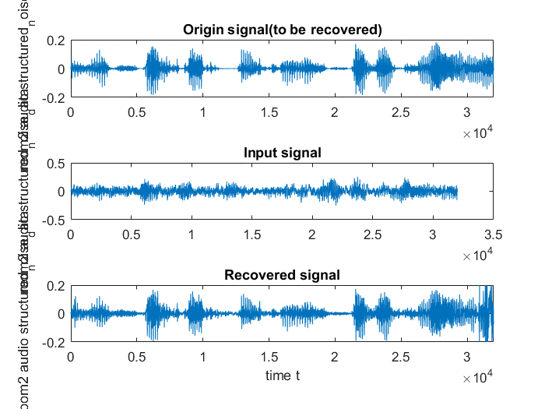

Figure 2.4.2 the comparison of the signal of origin, input and recovered(room1 with structured noise).

In total, for the unstructured noise, the filter converges slower and after the optimal ff, the ASE goes larger again while for the structured noise, the filter converges faster but before it with very large ASE. However, after reaching the optimal ff, it keeps its convergence.

Task 3

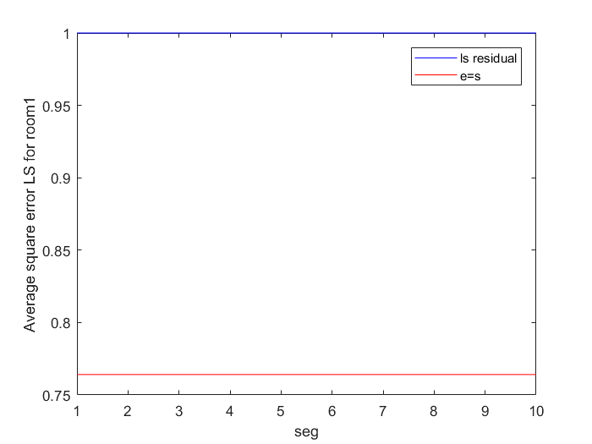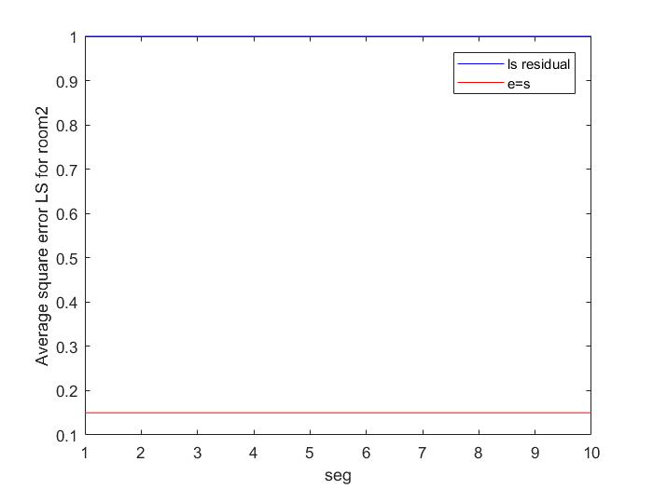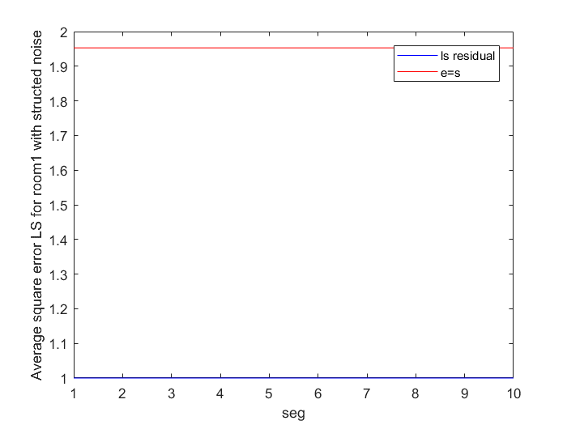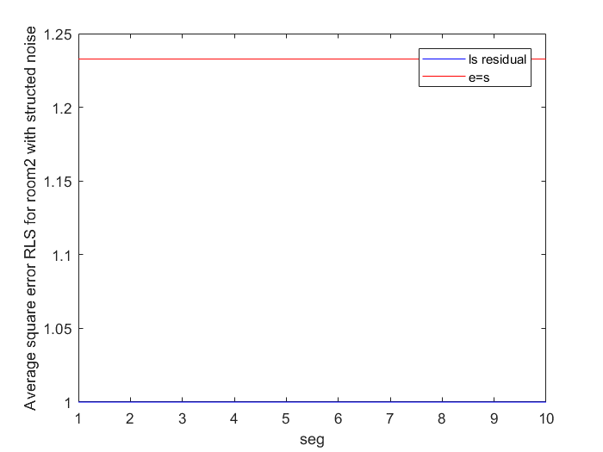

Unfortunately, for all the four signals , I did not get correct answer for this part. My problem is the error becomes very small which is close to zero(apparently cannot stands for our desired signal). Thus, the ASE does not change at all.

Task 4

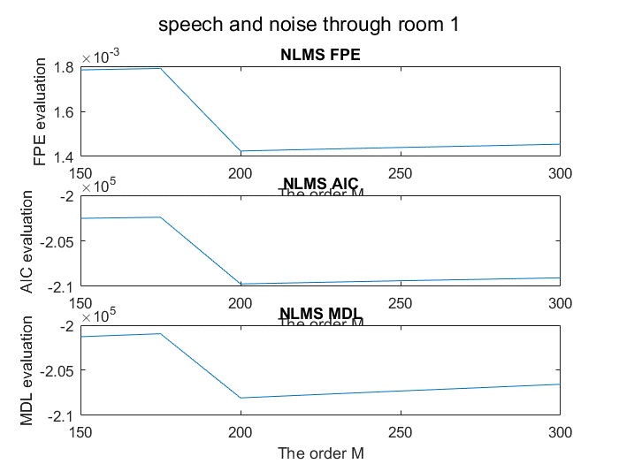

Figure 1.4.1 order choise with FPE, AIC and MDL criteria for speech and noise through room1

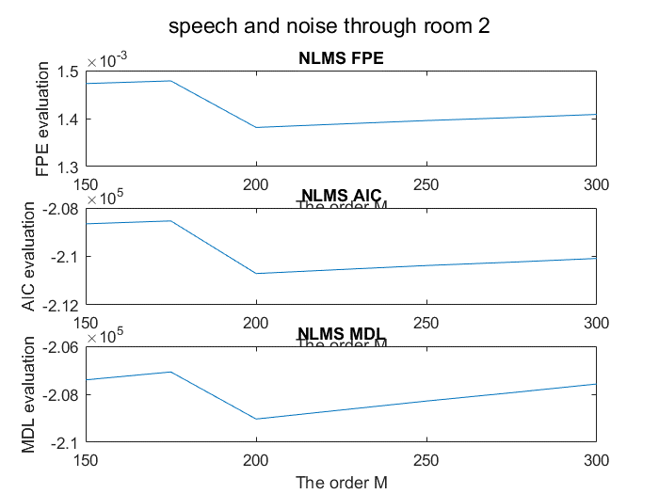

Figure 1.4.2 order choise with FPE, AIC and MDL criteria for speech and noise through room2

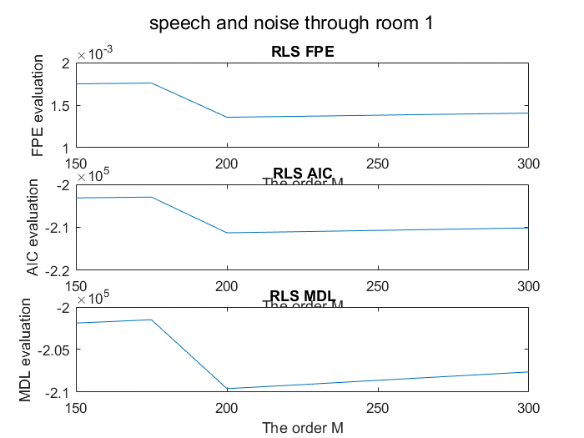

Figure 1.4.3 order choise with FPE, AIC and MDL criteria for speech and structured noise through room1

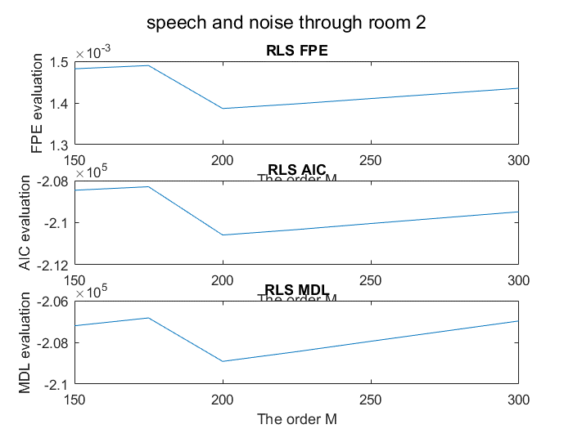

Figure 1.4.4 order choise with FPE, AIC and MDL criteria for speech and structured noise through room2

Interestingly, for all the signals, under all three criteria, the optimal order M is always 200.

Bonus tasks

Task 6

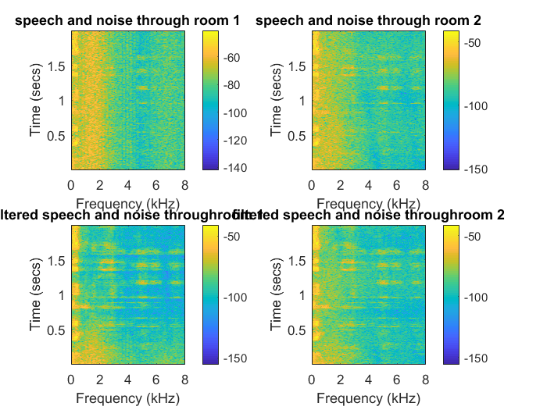

Figure 1(a b c d from left up corner to right down corner), the spectrum gram of the unstructured noise.

The filter’s effect is more significant for room1 than room 2 with unstructured noise.

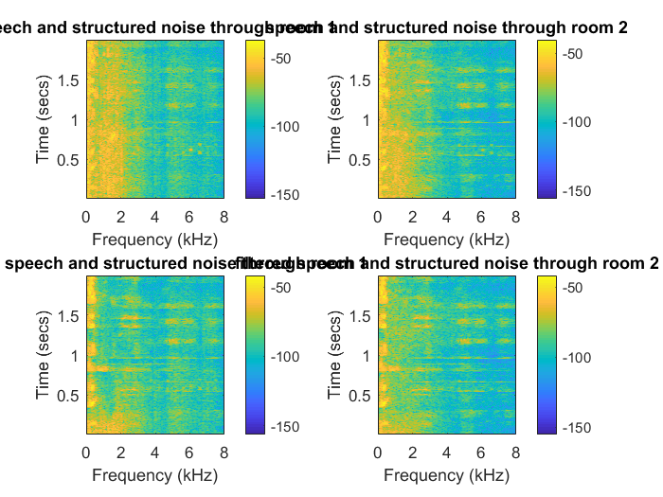

Figure 1(a b c d from left up corner to right down corner), the spectrum gram of the structured noise.

Similarly, the filter for structured noise also works more significant for room1 than room2 according to spectrum gram.

Periodogram function measures the power spectral density of the signal while the spectrogram of signal is the integral of the signal periodogram in terms of time axis.

Task 7

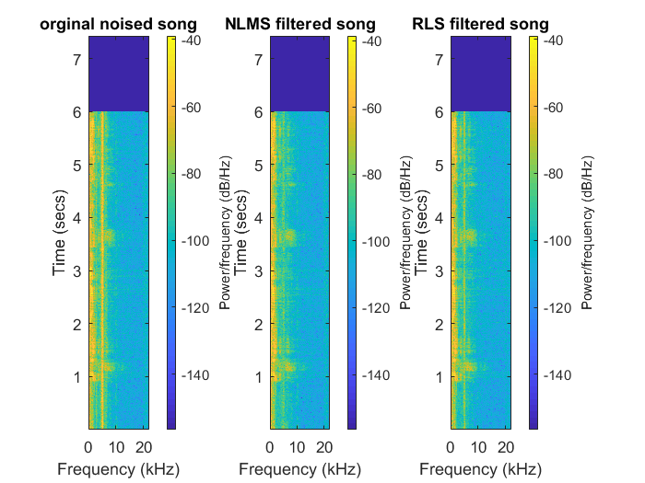

Figure 2.7 The spectrum gram of the real records. Original song(with cricket noise) is the left. Middle is the song after NLMS filter. Right is the song after the RLS filter.

It is obvious that the after applying the filter, the signal upper than 5 kHz is more smooth(the interpret of cricket is cancelled in some degrees). And the NL<S seems works better than RLS.

Task 8

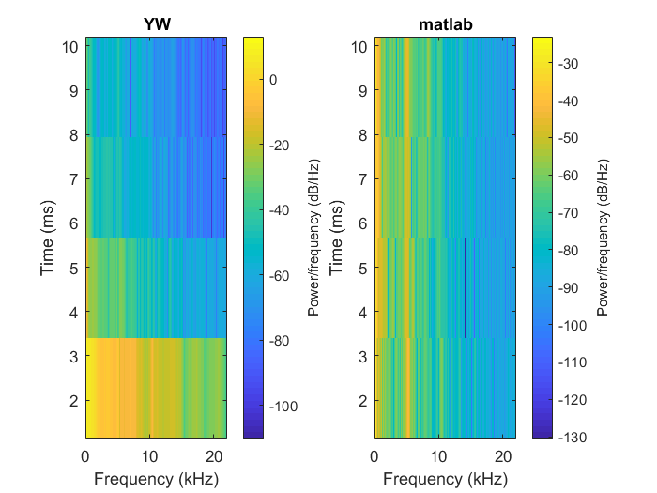

Figure 2.8 The spectrum gram of self-written Yule-Walker parametric spectral estimation(left) and the matlab buit-in function.(right)

The results are a little bit different(fits well). In total, the self-written one is larger than the built-in function’s solution.

Task 9

The best ASE of the NLMS is 0.0350 and with computing time of 0.46664s while the best ASE of the sparsity nonzero coefficients NLMS is 0.0330 with computing time of 0.155s.

From the results, we can see, after exclude the zero coefficients, the computing time is less and the best ASE is smaller as well.